Title:

nQativ - ACA Moving Forward: Monthly Processing and Activity HD

**Description:**

This session will educate participants about processing ACA requirements monthly in the current year. Instruction will include verifying designation records for qualifying employees, creating result records for the most recent measurement period, and creating and tracking notifications. Activity HD will be used to demonstrate each of the steps.

Show ACA Menu in Dashboard.

Focus on “ACA Monthly Operations”

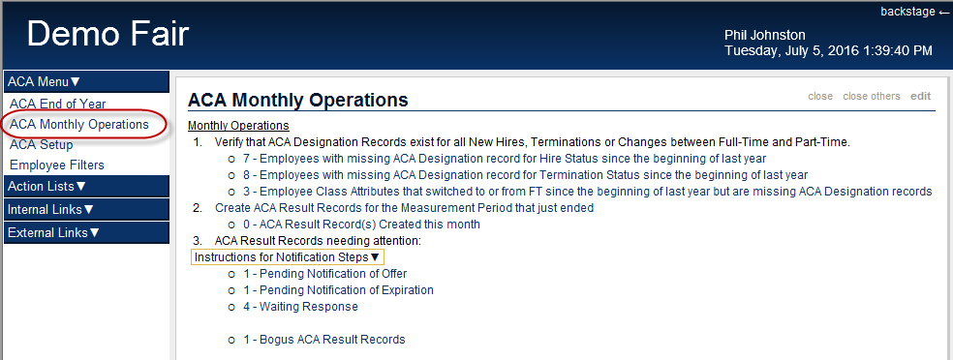

1. ACA requires employers to:
   1. Notify employees when they become eligible for health coverage
   2. Notify employees when their current health coverage is about to expire
   3. Keep records of employee notifications that have been made
   4. Keep records of employee responses to ACA notifications
2. ActivityHD can be configured with dashboard gadgets that will make it MUCH easier for HR staff to fulfill these requirements. The “***ACA Monthly Operation***” gadget found in the dashboard’s **ACA Menu** includes three main steps:
   1. Verify that the required ACA Designation Records have been created
   2. Create ACA Result Records based on the last completed measurement period
   3. Follow-up needed based on Result Records
3. End of Year
   1. Complete the ACA Monthly Operations for the last period of the year
   2. Proof 1095-Cs
   3. Print ACA Employee 1095-Cs
   4. Report to IRS with either the:
      1. Print ACA IRS 1095-Cs

OR

* + 1. Create 1095-C Transmittal file

Our focus today is the monthly process you need to perform to meet the ACA Employer requirements.

The “***ACA Monthly Operation***” gadget found in the dashboard’s **ACA Menu** includes three main steps:

1. **Verify** that the required ACA **Designation** Records have been **created**
   1. If any employees are missing designation records, click on that dashboard link to see the list of specific employees that have that problem.
      1. Double-click an employee (**Jane Jetson**) in the list to open that employee record and determine why they were indicated as missing a designation record.
      2. Demonstrate investigation and how to correct.
   2. Show the difference with the third link being on Employee Attributes instead of employees.
      1. Double-click employee
2. **Create** ACA **Result Records** based on the last completed measurement period
   1. The dialog prompts for which measurement period to analyze
3. **Follow-up** needed based on ACA Result Records
   1. Any non-zero count shown in the third section indication actions need to be taken
   2. Click on the **Pending Notification of Offer** line when it shows more than zero
      1. The employees listed have qualified for an offer of health coverage
      2. Each employee listed must be notified of their options for health coverage
      3. The link “**Notify Employees of Offer via Email or Print**” will run an Activity Bot that:
         1. Generates a Notification document specific to each employee that is pending notification of offer.
         2. The Notification document is either Printed or Emailed depending on the employee’s Distribution setting.
         3. A Note record is added to the employee and the ACA Result record indicating the employee has been Notified and a PDF copy of the Notification document is attached to that Note record.
         4. After running this Activity Bot, the HR staff person should verify any PDFs that printed match the newly created Note records with a description saying “Notified via Print”
            1. Of course any printed notification must be delivered to the employee
         5. The HR staff person should also verify that their sent email from Outlook matches the newly created Note records with a description saying “Notified via Email sent to <email address>”.
   3. Click on the **Pending Notification of Expiration** line when it shows more than zero
      1. The employees listed have health coverage that will expire in an upcoming stability period.
      2. Each employee listed must be notified of the upcoming expiration.
      3. The link “**Notify Employees of Expiration via Email or Print**” will run an Activity Bot that:
         1. Generates a Notification document specific to each employee that is pending notification of expiration.
         2. The Notification document is either Printed or Emailed depending on the employee’s Distribution setting.
         3. A Note record is added to the employee and the ACA Result record indicating the employee has been Notified and a PDF copy of the Notification document is attached to that Note record.
         4. After running this Activity Bot, the HR staff person should verify any PDFs that printed match the newly created Note records with a description saying “Notified via Print”
            1. Of course any printed notification must be delivered to the employee
         5. The HR staff person should also verify that their sent email from Outlook matches the newly created Note records with a description saying “Notified via Email sent to <email address>”.
   4. Click on the **Waiting Response** line when it shows more than zero
      1. The ACA Result Records listed will be for those employees where we haven’t recorder an employee response.
      2. This might indicate that the employee needs to be reminded of the offer or of the expiration.
   5. Additional Activity Bots to help record the Employee’s responses:
      1. **ACA Note as Selected**
         1. For each selected ACA Record
            1. That is a Result type (not Designation)
            2. That has a Notify Note with a Type set to “ACANotifyOffer”
            3. And doesn’t already have a Response Note
         2. Create a new PR Note record with:
            1. Note Type set to “ACASelected”
            2. Description set to “Selected plan”
            3. Date set to now
            4. References set to this Employee and this ACA Record
         3. Update the ACA Record with a Response Note reference to the newly created PR Note record.
      2. **ACA Note as Declined**
         1. Similar to the Bot above except updating as Declined instead of Selected
      3. These newly created Note records are where you would want to attach any documentation from the Employee like a scanned copy of the signed health coverage offer letter with the employee’s response.

Contact us:

[support@nqativ.com](mailto:support@nqativ.com)

Phone: 800.354.7152

If you need a quote for adding the ACA dashboards or for ACA Implementation,

please contact Tim Evans at [tevans@nqativ.com](mailto:tevans@nqativ.com)